**HousePoint Blog**

**Blog Post 1: A sneak peek into real estate in Nigeria**

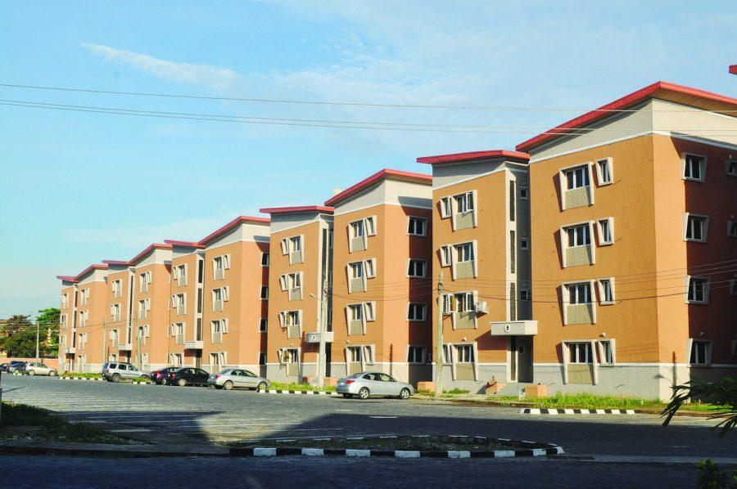

Nigeria's real estate market has expanded rapidly as the demand for housing, retail and office space is on the rise. However, the industry faces a number of pressing challenges. The real estate business in Nigeria is widely regarded as “high-risk, high-return” and is one of the most opaque in the world, ranking 96th out of 97 nations surveyed in the 2012 Global Real Estate Transparency Index devised by JLL, a US-based real estate consultancy. The risks involved are a derivative of the complex and outdated regulatory environment. The costs associated with procuring/building, transferring and registering a piece of property are exorbitant, which is why many Nigerians still cannot afford to buy a house, especially in fast-growing urban areas. These make people resort to self-built informal housing.

**Informal Housing**

The real estate industry is regulated by a variety of ministries and official entities, with the Federal Ministry of Lands, Housing and Urban Development (FMLH) being the fore-runner. A number of state entities are also involved in the real estate sector in various ways. Despite the recorded growth in the real estate sector in recent years, most Nigerians live in informal settlements. Statistics show that some 70-80% of Nigeria’s nearly 170m people live in unplanned , self-built settlements. According to the UN, about 70% of the population in Lagos live in slums, while a bulk of city dwellers rent their homes, which costs around 30-40% of their income. In general, the costs of buying and maintaining formal housing are well out of reach for most Nigerians.

However, residential, office, retail and hospitality space is located almost exclusively in urban areas, especially the three key markets of Lagos, Abuja and Port Harcourt. Lagos is among the largest cities in Africa and by far the largest in Nigeria and is considered Nigeria’s primary destination for property investment and new developments. State investment projects has influenced a steadily growing amount of property investment in Abuja in recent years. Port Harcourt, the capital of Rivers state is a major abode for oil and gas industry, where property investment is ever-growing.

**Residential Housing**

Developers In Nigeria generate greater percentage of their revenue from the high-end luxury residential segment. Most of the areas in prime development command housing prices that rank among the highest in Africa. Some of these places include Banana island, Ikoyi, Lekki, Victoria Island in Lagos; Asokoro, Maitama, Jabi in Abuja; and GRA Phase 2 in Port Harcourt. The annual cost of renting an apartment in Ikoyi was $50,000-100,000, while owning an apartment started at N100m ($610,000), as of 2013. Most leases require two years’ worth of rent to be paid up-front., due to high cost of owning, renting and maintenance of a building.

**Affordable Housing**

Improving access to affordable housing has become priority for the government. There are fixtures made by the government that aims to lower the cost of mortgages by buying up packages of existing loans to provide low-cost, state-financed mortgages. Many Nigerians cannot afford formal housing as earlier mentioned, at the end of 2012, about 61% of the population lived on less than $1 per day. Economy decline has not helped this situation till date.

The state could do more than offer mortgages directly in order to make housing more affordable. Land registration process need to be more transparent and less time-consuming.

**Office**

Nigeria has Africa’s biggest economy and the demand for grade-A office space is on the rise, day in, day out. The large gap between supply-demand has inflated the cost of office spaces, rents of such spaces in primary areas like Ikoyi, Victoria Island are among the world highest.

These high rates are widely expected to drop in the coming years, given the massive amount of new office space currently in the pipeline.

**Hospitality**

The increase in local and global investments has relatively increased the need for more hotels, restaurants and other hospitality firms. Developers are drawn to this demand and a cluster of new hotels have gone up in Lagos, Abuja and Port Harcourt.

**Blog Post 2: How to maintain your new space**

**Maintaining your new space is important for a healthy and safe home environment. A house or office space that is kept clean and well maintained as at when due will less likely develop problems that make the environment unsuitable.**

**Problems associated with poor space maintenance**

**These problems range from poor air quality in the form of mold and other allergens, to drafts, disease carrying rodents and invasive insects. Even problems with dangerous gases such as radon may prove a problem in homes that do not have home maintenance plans in use. Fortunately your household cleaning or home maintenance checklist does not have to be overwhelming in order to be effective.**

## **Observe Your House**

**Observing is not figuring out. It is not analysis. Observing is a wonderment. It is open and receptive. It is true learning. Once you can observe potential problems around your home, then what? You can learn where to look and for what. Below are nine quick areas to observe.**

1. **Siding at lower levels, deck connections, under windows and doors, around chimney.**
2. **Sagging or cracked masonry stoop, steps, or foundation; erosion.**
3. **High-stress windows and doors, sills, and caps, i.e., those without overhangs or with southern exposure or without storms or gutters.**
4. **Trim around chimney, under roof valleys, under poorly hung gutters, at corners or ends, discolored or mildewed wood.**
5. **Water that collects or runs toward the house.**
6. **Floors that are soft, unstable, or discolored near exterior doors; in bathrooms around toilets and tubs; cracking kitchen tiles.**
7. **Discolored or peeling paint inside or out.**
8. **Cracks in walls, especially emanating from window and door corners.**
9. **Basement or crawlspace water or sweating ductwork.**

**Use all of your senses to observe. Look for texture and color changes. Look for things not level or plumb. Look for cracks, water, bugs and ants, etc. The eyes can spot much, but also pay attention to your feet. When walking, does the floor seem unstable or soft? Listen for noises or squeaks. Touch discolored areas to see if they are damp. Smell for musty odors. Does anyone start sneezing or have difficulty breathing or get a headache when in a certain area?**

## **Control Dust**

**Dust has the potential to be a serious health hazard. Not only does it contain the skeletons and feces of dust mites, which cause allergies and aggravate asthma, but it may also carry chemicals that have come off items that have been in the home, such as lead and pesticides. When dusting, use a dampened cloth so that the dust will better adhere to the cloth. Items such as throw rugs should also be routinely washed.**

**For extra help,** [**contact a cleaning pro**](https://www.improvenet.com/GetStarted/Cleaning/Step1) **in your area.**

## **Keep Floors Vacuumed**

**Carpets should be vacuumed no less than twice a week. The most effective vacuum cleaner is one that comes with a HEPA filter. Vacuuming will not only help to remove dust, but it will also remove pet dander, fur, dirt and other contaminants that could sicken persons inside the home. When vacuuming, move and vacuum behind furniture and other objects. To help keep dirt levels and other harmful substances out of the house, remove shoes before entering. Shoes can track anything that has been stepped on into the home, such as dirt, feces, chemicals, and more.**

## **Check the Exterior**

**Inspecting the exterior of the house is an important part of all home maintenance plans. Look for signs of wear and tear and make the appropriate repairs. Check for decay or damage to the trimming around doors and windows. Repaint and repair home siding and trim that has become loose or where paint has begun to peel.**

## **Check Windows and Wall**

**Both windows and walls can be a source of health problems if not well maintained. Inspecting and repairing both areas should be a part of a person's spring and fall home maintenance checklist. Prevent drafts and excess moisture from entering the home by replacing or repairing any caulking around the home's doors and windows. If windows are cracked they should be** [**replaced or repaired**](https://www.improvenet.com/r/costs-and-prices/window-repair-cost)**. The walls in the interior of the home should also be carefully checked for evidence of termites. Check that screens are intact to ensure that certain types of pests are being kept out.**

## **Keep Moisture Under Control**

**Moisture in the home results in mold which can cause numerous health problems. In addition, moisture is also attractive to rodents and insects. To reduce these risks make any repairs to leaky sinks or pipes as quickly as possible. Use exhaust fans in the kitchen and bathroom to reduce humidity while cooking or showering. In absence of exhaust fans, open windows. Leaking roofs should be repaired as quickly as possible.**

## **Keep Air Filters Clean**

**One often overlooked aspect of home maintenance involves the house air filtration system. Dirty or clogged air filters can result in damage to air conditioning systems, or even in extreme cases, a breakdown or a fire. Filters in portable air filtration systems are also vulnerable to becoming dirty or clogged. Clean air filters can help keep pollution out of the air. Fortunately, keeping air filters clean is as easy as** [**taking them out and either replacing them**](https://www.improvenet.com/a/video-how-to-change-a-furnace-filter) **or cleaning them. Cleaning filters can be as simple as removing them and shaking them clean, while in other cases one can wash them or brush them off. It is best to clean any kind of air filter outside to keep dirt from circulating in the house. This should be done once a month.**

## **Maintain Heating and Cooling Systems**

**Heating, air conditioning and other types of climate control systems work by circulating hot or cold air through the house. As a consequence, they can become a major potential conductor of pollution in the home. Periodic cleaning of vents and the cleaning or replacement of filters is an essential part of a healthy home maintenance checklist. Regular maintenance of climate control systems is also necessary in order to prevent performance losses or even breakdowns.**